Creston Improvement Association
Summer 2014 Newsletter
Annual Meeting Minutes  Our meeting was held on June 24. We set the date for our annual party after discussing last years. Attached is the flyer for our party, Sunday, August 17. We also discussed potential events and activities for the neighborhood such as a progressive dinner, a HAM radio demo, special interest groups (wood working, book club, etc.).  Speed issues specifically on Starling and Creston Drives was also discussed as was yard appearance, our trash cans back off the street and keeping shrubbery cleared near the street. Drivers need visibility particularly at corners and around curves. See website www.creston-ca.org. or our News folder for full minutes and financial report, http://wwwcreston-ca.org/news/ . |  | Annual Creston Party  Sunday August 17 at 4 p.m.  August 17 is the Date. Your neighbors will assemble on Alderney Court for some great food and conversation for the whole family. Party begins 4:00 pm; Dinner at 5:00 pm Please return your RSVP form ASAP.  Internet Password Protection  Some Creston web documents include occasional phone or email that is intended for Creston folks only. These will be placed in a web folder that is accessible only by a Creston username/password. The current username is "creston" and the password is "foothills14". We will build up a library of documents of interest to Creston residents, changing the password occasionally to limit unwelcome exposure.

 | 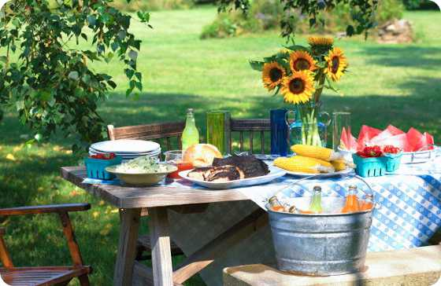
Meet the Singh Family  Late July last year Jasvinder, Jasneet, Jahnavi and Jiya moved to Creston Drive from San Jose. The Singh family hails from North India and migrated to the Bay Area in 1996(Jasvinder) and 1998(Jasneet). They lived in Santa Clara for a couple years and then moved to San Jose for 13 years before making the Creston Community their destination. ( go to page 2 ) |  | Meet the Pitts Family  Liz and Phil Pitts moved into their house on Ainsworth last summer. They sold their home in the Rose Garden Area of San Jose to relocate to a quieter neighborhood, and they were up for the challenge of a new project. They both are very community oriented as Phil worked for the City of .. ( go to page 2 )

More of the Singh Family  Jasvinder graduated from IIT Delhi (India) with a Master’s degree in Computer Engineering. Right after graduation, he moved to US and joined Cadence Design Systems where he worked for 10 years. Currently he is employed with Synopsys at Mountain View so moving to Creston has cut down his commute by half. Jasvinder loves to hike at Rancho San Antonio and enjoys a game of Tennis whenever he can.  Jasneet graduated from BITS Pilani(India) with a Master’s in Computer Science and after her marriage with Jasvinder moved to US in 1998. She is currently employed with Qualcomm in San Jose where she works as a program manager. Jasneet is also nationally certified aerobics instructor and teaches Step aerobics, Zumba and Bollywood aerobics at various gyms in the Bay Area.  Jahnavi is entering junior grade at Archbhishop Mitty High School and aspires to pursue a degree in medicine. Jahnavi actively participates in the school debate team and runs a dance club in the after school hours. Outside of school, she runs at a competitive level and has won many medals along with competing in roller skating till a couple years from now. Jahnavi’s passion however lies in dancing and has been with a Bollywood dance company since she was 9 yrs. old. She has recently moved up to be an instructor and teaches dance to young kids 3 hours a week.  Jiya is entering 4th grade at Steven’s Creek Elementary and loves to be in the neighborhood school with her class friends just around the corner. Jiya loves to write and sing and wants to be an author and singer when she grows up. Jiya, Jahnavi and Jasneet spend a few hours every month volunteering for a non-profit organization for underprivileged children.The Singh Family (or the J family!) is very happy to be in the Creston Community which they find to be extremely friendly. They hope to be involved and contribute towards the community in whatever possible way. They like to make friends and socialize. On Sunday evenings, you will find them playing boards games (no electronics), so if anyone will like to stop by they are always welcome! | More of the Pitts Family  San Jose as a Motorcycle Officer for 20 years, then retired out. He was too young to be retired, so he began a career as a General Contractor. Phil was always interested in finance, so he obtained an MBA with a specialization in finance. Phil taught business classes at Sierra College until becoming a Mortgage Loan Agent. This eventually progressed into taking over Amerimac Cal-West Financial Inc., as the Broker/CEO & President.  The company always has been community involved, and continues to serve the public. Phil diversified in the direction of Reverse Mortgages to assist families and their heirs to remain in their homes. As you can see, his idea of retirement does not quite include Rest, Resorts, or Relaxation at this point. They love to play golf, but unfortunately don’t seem to find the time lately. Liz Pitts began a career as a hairdresser before she had children and she always appreciated the luxury of being a full time Mom to their two kids, Michelle and Kenny. Michelle is 36 and is the Departmental Head of Special Education at Gunderson High School. She and her husband Matt, a Police Officer for the City of San Jose, live in San Jose with their two children. Mason Leo is 3, and Maxwell Logan is 11 weeks old. The Pitts’ son, Kenny, is 34 and lives very close to his sister, working as the Operations Manager for Amerimac Cal-West Financial.  Liz Pitts began attending college and taking classes as their son was ready to graduate from high school. She achieved her lifelong goal of becoming a nurse after 4 years of hard work. Liz decided to follow her heart to serve the community better and embarked on a 10 year endeavor as a BSN Hospice Nurse. Serving families during this mysterious and often magical time in one's life was very important to her. Liz has taken the summer off to be with their new grand baby Max, and to play with Mason, which she has loved. The Pitts divide their time between their home in Tahoe Donner, Truckee and San Jose to be with their family. They recently purchased seats in Levi Stadium to attend the Niner games (Go Niners!), and look forward to the home games with their family. They also look forward to the ongoing work on their house, and plan to make this home their haven. They are very happy to join the neighborhood.

Roof Replacements  One of our neighbor suggested that the summer is a good time to replace your roof if it needs it. Due to the drought, many roofers are not getting the business levels of the past and can offer better deals. Check our website (www.creston-CA.org) for Service referrals which are mostly recommendation by Creston people. | Blackberry Farm  Did you know that Blackberry Farm in the Monte Vista area of Cupertino has been upgraded and restored to improve the natural habitat? A neighbor said you can get family passes. Her grandchildren love it as did her children 30-40 years ago. There is a water slide, horseshoes, bocce ball and much more.

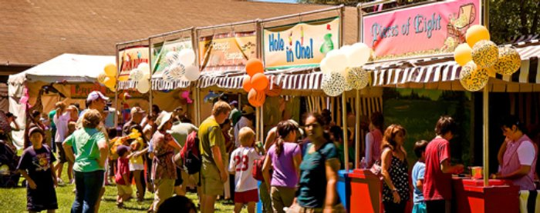

Emails / Neighborhood Alerts  Content of our email bulletins are notices of meetings, lost/found animals, wildlife sightings, sheriff reports and many other items of interest to the neighbors that can’t wait for a newsletter.  To be added to our distribution, contact Pat Musachia at:  g.musachia@sbcglobal.net | Protect Your Pets:  One recent e-mail bulletin was regarding a missing cat from Alderney Ct. Unfortunately, it appears that Achilles was killed by another animal. Many are missing this friendly cat. It may have been a coyote that killed him. It’s been quite a few years since we’ve had any cat killings but this can happen. Coyotes, bobcats and deer come into our neighborhood via both the creek and railroad tracks. Best advice is to keep your cat inside at night, if you can. Bobcats can be daytime visitors. Let Pat know if you see any critters and she can send out an alert.

Annual Neighborhood Party
Sunday, August 17, 2014
We’ve held these annual All-Neighborhood parties for almost four decades now. This tradition represents the heart of living in Creston!
Please come join the FUN (for all ages):
Meet your neighbors and enjoy good food & friendship.
As always, we’ll rent a big jumper-house for the children!

WHERE: Alderney Court (1st cul-de-sac off lower Creston Drive)
TIME: Party begins 4:00 pm; Dinner at 5:00 pm
WHAT THE ASSOCIATION PROVIDES:
The Creston Improvement Association Party Committee provides hamburgers, hot dogs, veggie burgers, chips, salsa, beverages (sodas, beer, wine, water), plates, napkins, utensils & cups.

WHAT EACH FAMILY NEEDS TO BRING:

A homemade contribution for our traditional, delicious International Potluck Buffet:

- We encourage you to share that special dish you enjoy, especially something that evokes the heritage, tradition or ethnic experience you draw from, or have encountered.
- Your own chairs, for seating.

R.S.V.P. Deadline: August 11th!!
Complete and return the attached Reservation Form no later than Monday, August 11th.
Drop-off boxes for your convenience are on the front porches at:
Pat Musachia’s, 22180 Alderney Court
Kitty Wilson’s, 22433 Ainsworth Drive
**We must have your attendance head-count and entrée food choices in advance**

You may also provide this information for your family to Party Chair Pat Musachia by email: g.musachia@sbcglobal.net.

